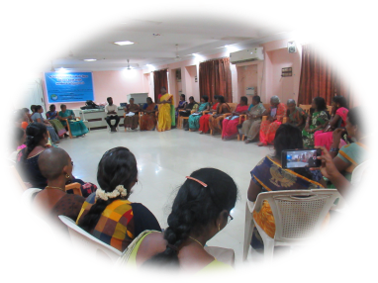

Annual Report for
FY 2023- 2024
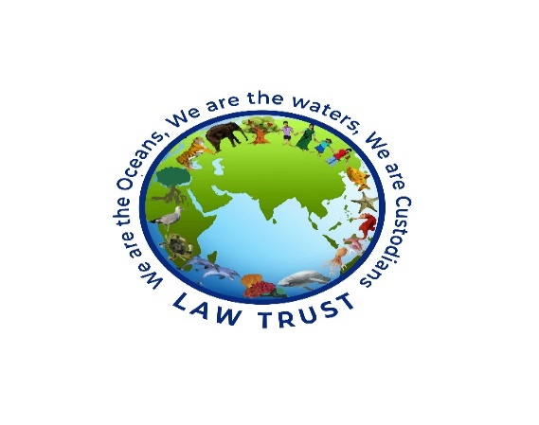

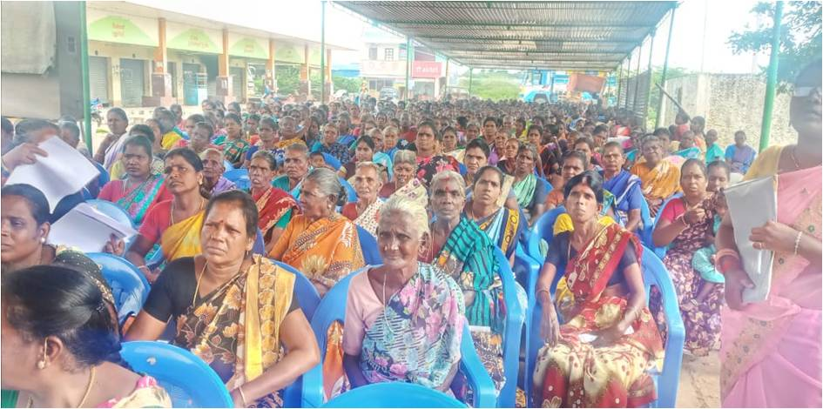

Foreword
Dear Friends,
As we reflect on the past year, we are filled with immense pride and gratitude for what we’ve accomplished together. This year marked a significant chapter in our journey, defined by resilience, innovation, and an unwavering commitment to our mission.
We navigated challenges, celebrated milestones, and strengthened the foundation of our organization. Our team’s dedication, creativity, and shared vision were the driving forces behind every achievement, from launching transformative initiatives to expanding community members, empowering our women leaders and children creating lasting value for our supporters. We believe in building not just an alliance of community members across caste ,class ,gender but a legacy of traditional fishing communities who are rooted in integrity, sustainability as custodians of oceans and coast .
As we step into the future, we do so with renewed energy and optimism. The opportunities ahead inspire us to aim higher, work harder, and stay true to the values that define us. We thank our donors, primary stake holders, women leaders, members of TNWFS, CAN, Friends, Board members, likeminded forum and networks, Auditing team and our team for your trust, support, and belief in our vision. Together, we are building something extraordinary.
Here’s to another year of growth, innovation, and shared success.
Warm regards,
Managing Trustee cum Director
Law Trust
30th June 2024

Board Member and their Designation

- Ms. Jesu Rethinam., Founder Trustee
- Ms.A. Gandimathi ., Director & Managing Trustee
- Dr. R. Rohini Devi, Trustee
- Ms. Ranjani Krishna Murthy, Trustee
- Ms. Manohari Doss., Financial Trustee
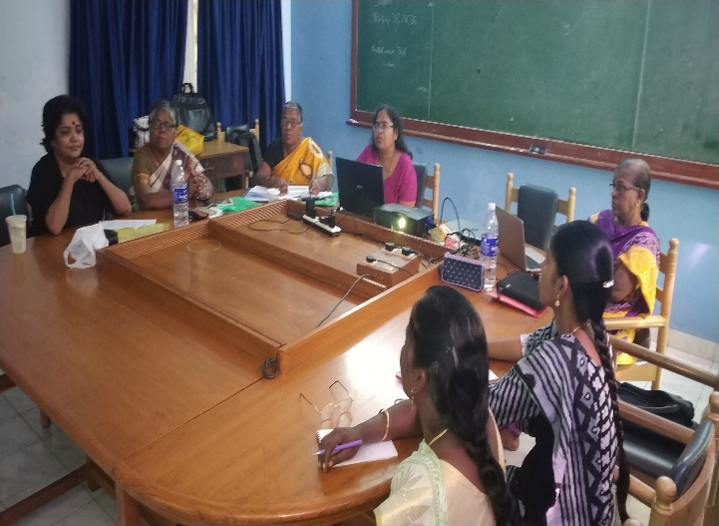
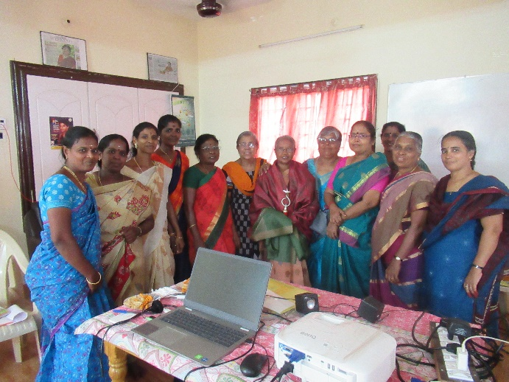
Team Member Details
- Ms. A. Gandimathi., Leader cum Director
- Ms. Jesu Rethinam., Consultant
- Mr. Selvaraj., Consultant
- Mr. Rajkumar., Office Associate
- Ms. Meenakshi., Support service
- Ms. V. Vijayashanthi., Child Rights Coordinator
- Ms. S. Jothilakshmi., Finance associate
- Ms. Kala., Field Coordinator
- Ms. Mary Glothu., Community Educator
- Ms. Sridevi., Community Educator
- Ms. Suganya., Field Coordinator
- Ms. Indumathi., Community Educator
- Ms. Revathi., Community Educator
- Ms. Lathika., Community Educator
- Ms. Sowntharya., Community Educato

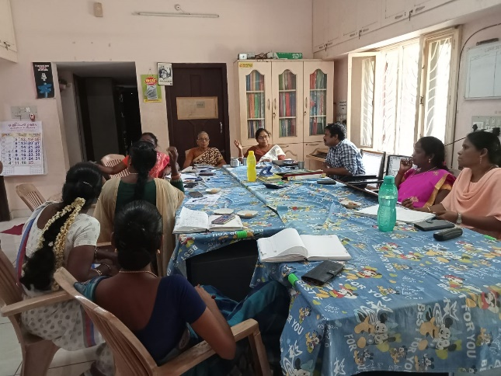
Vision
Striving towards social, gender, economic and ecological justice for coastal communities
Mission
Protect and promote coastal ecology and the traditional rights to coastal, marine and land resources of traditional fishing communities through grass root, Development and advocacy intervention in 14 coastal Districts of Tamil Nadu.
Ideology Socialist feminist perspective
Approach- Human Rights approach
Target Communities
Traditional fishing communities, Fisher women, coastal children, elected representatives
Domain
Coastal Ecology, Traditional Fishing Communities, Livelihood, Governance and Child Rights
Values:Integrity,Freedom,Accountability, Equality Innovation, Sustainability, and Transparency
Need for the project:
As the mission of Law trust was to protect and promote the civil, political and economic rights of the coastal communities and coastal ecology, the programmes were designed and activities were planned to achieve the same
Context
The coastal ecosystems occur where the land meets the sea and that includes a diverse set of habitat types like the mangroves, coral reefs, seagrass beds, estuaries and lagoons, backwaters etc. These ecosystems provide a wide range of services that includes provisioning services (fisheries); regulating services (carbon sequestration, prevention of erosion, moderation of extreme events); supporting services (element and nutrient cycling) and cultural services (tourism and recreational). The quality of the ecosystem services depends on the resilience of the ecosystems.
However, these ecosystems are facing a multitude of local and global challenges caused by human activities such as urbanization, industrial and infrastructure projects, over fishing and effluents and sewage from industrial sector have become a serious environmental issue in estuaries, bays and coastal waters causing eutrophication and unusual phytoplankton blooms resulting in significant reduction of fishery harvests, toxic algal blooms, and loss of biodiversity. Similarly, the natural influences such as global warming, increasing frequency of heat waves, cyclones, extreme events of precipitation and flooding, sea level rise, alterations of global hydrological cycles and changes in monsoonal behaviour etc. affect the functioning of biogeochemical cycles of these coastal ecosystems. As law trust is working in two coastal districts
Pathways for change
By recognizing the customary and governance rights of the traditional fishers in Muthupet and Pichavaram Lagoons and fostering their involvement in sustainable resource management, it is possible to ensure their economic well-being.
Restoring and enhancing its ecological services of Lagoons, such as nutrient cycling, carbon sequestration, water purification, and biodiversity support This will resulting livelihood promotion of SSF and women fish workers and over all wellbeing of the communities.
The community governance will ensure ecological resilience, the ability of an ecosystem to maintain its normal patterns of nutrient cycling and biomass production after being subjected to damage caused by an ecological disturbance.
More over the community will have sustained ability to use available resources

Activity Profile from April 2023- March 2024
Domain | Integrated proposal for protection and promotion of coastal ecology and civil, political and livelihood rights of the coastal communities in Tamil Nadu | Sustainability of SSF fishery livelihoods and coastal ecosystems management and ensure inclusive participation and good governance, and promoting gender equality. | Strengthening the Muthupet Lagoon Project | Out Reach/ impact | Application of Technology Infrastructure Partnership.
Coastal Ecology | Beach Profile  Resource Mapping  Litigation support  A state level consultation on the implications of Forest Rights Act on livelihood and housing rights of the Coastal communities | Generation of Data on commons  Beach Profile  Resource Mapping | Historical Mapping  A state level consultation on the implications of Forest Rights Act on livelihood and housing rights of the Coastal communities. | The TF and Fish workers were able to claim the right to navigate in Koraiyaru and Valavanaru for fishing in Lagoon Sea. Fish workers are allowed to collect Oysters, Prawn and crab using the provision of FRA 2006.  Sustainability of Livelihood  Access to Income  Access to Nutrition food  Identification of invader species. | Emery method for beach profile  Partnership with TISS  Coordination and collaboration Coastal Action Network, NFF,  CFA, WFFP, ICSF, SSF HUB  Advocate Mr. Yogeshwaran,  Dr. Mr. Jones Spartacus, Consultant and Mr.Selva Raj, FRA activist Mr. Armaan, Ecologist
Traditional Fishing Communities (TFC) | Networking the coastal defenders to mobilize support for the protection and promotion of coastal communities and ecology - Coastal Action Network  State level consultation for State and District Committee Members of TNWFS to evolve strategies to assert their civil, political and economy rights.  Perspective building programmes on community resilience ecological integrity and habitat protection by Integrating Pandemic Perspectives for SSF & Women  Observing World Fisheries day on 21st November | P.2.1 Policy dialogue and legislative measures for promoting customary and governance rights  Networking National SSF/women movement to play active role at the regional and international movement  P.2.2 Observing World Fisheries day on 21st November  P.2.3 Policy dialogue and consultation with ministry appropriate official of the Union and State Government for reservation and delimitation | P.2.1 Forest rights implementation for resources Dependent communities  Observing World Fisheries day on 21st November | Collection of Testimonies from TFL on destruction of mangroves  Decline in Fish catch  Reduction in income  Climate change  Resolutions submitted Women Fish workers to MLAs and MPs | Coordination and collaboration Coastal Action Network, NFF, CFA, WFFP, ICSF, SSF HUB
Livelihood of Women fish workers | Skill training on Leadership, Business skills and Vocational skills  Interfacing and dialogues with MLAs, MPs, PRI Representatives, Authorities and Ministry for securing infrastructure facilities and marketing entitlement. | P.2.1. Interfacing and promoting Linkages with DIC Fisheries Dept officials and NABARD  P.2.2 Sensitization of target communities on policy and legislative and economic programs for social and economic empowerment of SSF and women | - Capital support to 80 Women Fish workers | Annapanpettai, Killai ME groups were able to mobilize the support to the grant of 85 lakhs  Increase in income  Loan Repayment | Collaboration with NABARD, DIC, Nationalised Banks & Fisheries department
Governance | Regional workshop for capacity building of elected women representatives and electorates in coastal districts about their rights, duties and functions under Panchayat Government  Capacity building of Women Panchayat Presidents of Thiruvarur and Cuddalore Districts |  | p.1.1Interfacing with local administration, passing resolution in Forest rights committee to reclaim commons and access rights to forest resources | Submission of memorandum to MLAs and MPS and leaders of Political parties. | Collaboration with panchayat Government and elected representatives of Legislative assembly  Coordination with ROOTS, THANNATCHI, HRDF, SNEHA and Elected representatives working with Coastal, Tribal and Dalit communities
Child Rights | Awareness creation for members of children’s Panchayat including school children in 2 districts on legislation related to child protection and child participation.  Networking / Monitoring interventions to strengthen the institutional mechanisms of the legislations for child protection  Regional consultation for evolving the strategies for stringent implementation of child related acts to ensure the protection and participation of children in coastal districts.  P.1.4 Regional workshop for perspective building of child rights defenders on child rights legislations and institutional mechanisms |  |  | Submission of status report to Justice Chandru commission on observation homes and child care centres.  210 children were trained on child rights protection and institutional mechanisms for Child participation and protection of Coastal defenders were trained to develop a tool kit and strategy for effective implementation for SMCs and CPU. | Collaboration with TNCRW, ANBALAYA, CSED and VIDIYAL as Resource team  Supported by TFC, WC and Local school Administration  Solidarity from Coastal NGOs

Highlights (April 2023 to March 2024)
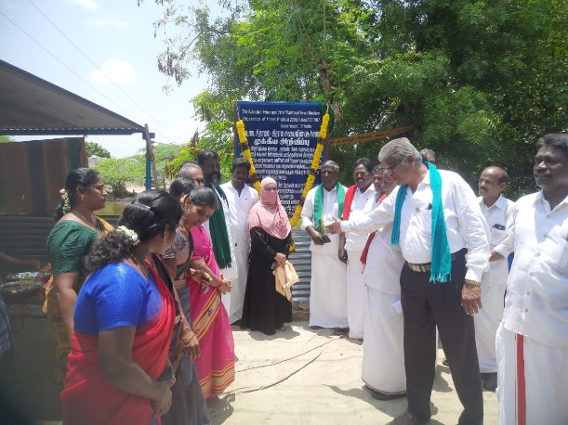
Coast

Reclaiming right to navigate in Koraiyar river to reach the lagoon and sea for fishing by traditional fishers and fisher women using Non mechanized boats and collection of oysters by traditional fishing communities using FRA 2006 Act in Pettai, Sengankadu and Munankadu, Muthupet Taluk in Thiruvarur District.
Declaration Board installed by the forest rights committee and honoured by MLA, Union Chair person, Comrades from CPI, CPM, VMDS on 22.08.2023 at Pettai, Thiruvarur
Stalling Public Hearing to withdraw CZMPs under CRZ 2019
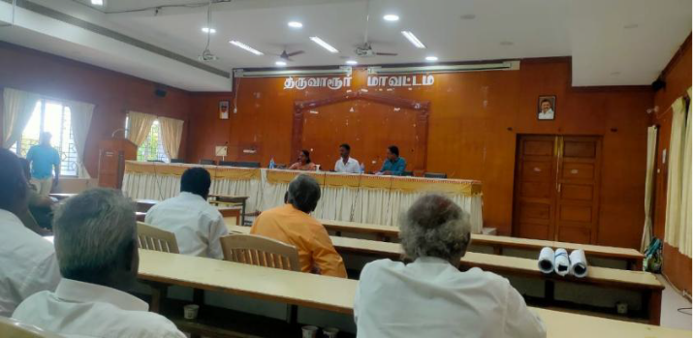
Stalling public hearing held by the District Administration to demand for withdrawal of CZMPs, as the draft CZMPs was planned without the participation of Fishing community. Many of the details were missing: Village commons, Boat landing space, Net mending centres, Drain channels and habitats. Hence the coastal communities protested and the community leaders and member of TNWFs submitted a petition in District Collector in Thiruvarur District on 05.08.2023
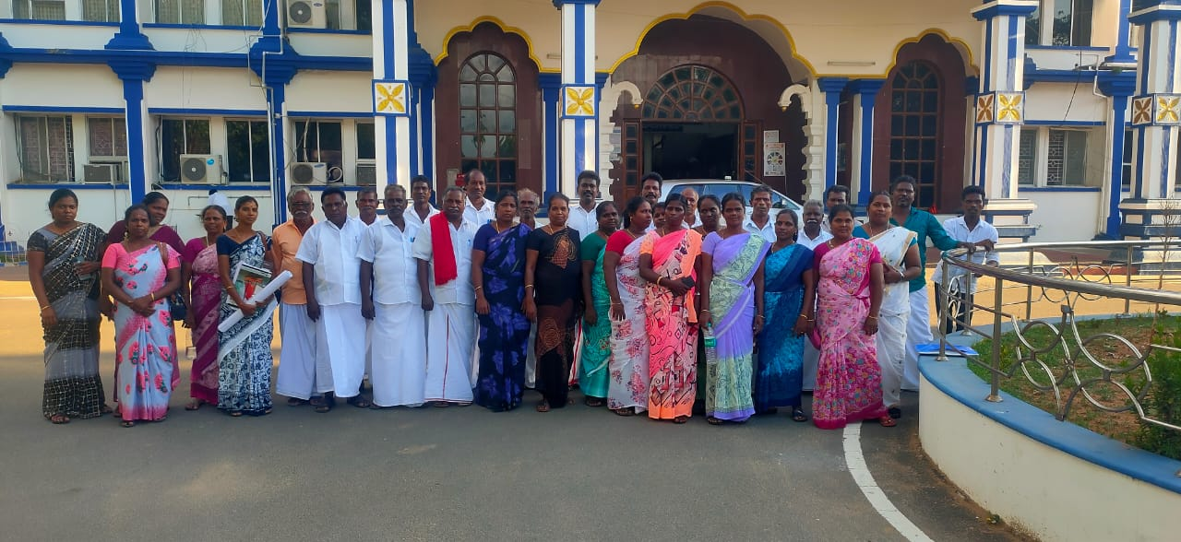

Strengthening the advocacy against industrial shrimp farming at National level consultation on 9th and 10th Jan 2024
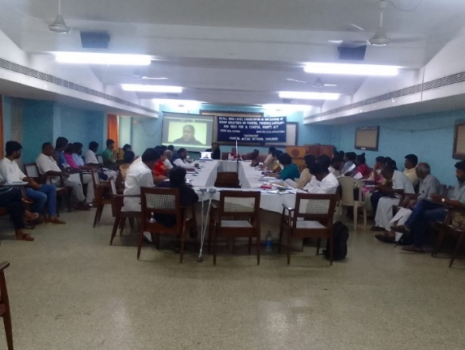
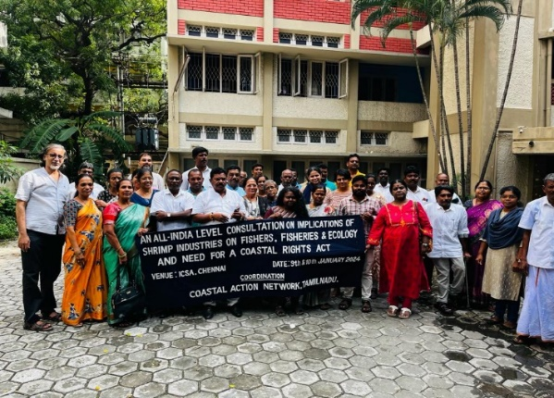
The consultation challenged the legality and implementation of Coastal aquaculture Act and CAA will be challenged by the unions of coastal states in their respective High Court Jurisdiction and collective writ petition in Supreme Court against the implication of industrial shrimp farming and seeking ban for the same.

Training on Forest Rights Act at Sengankadu
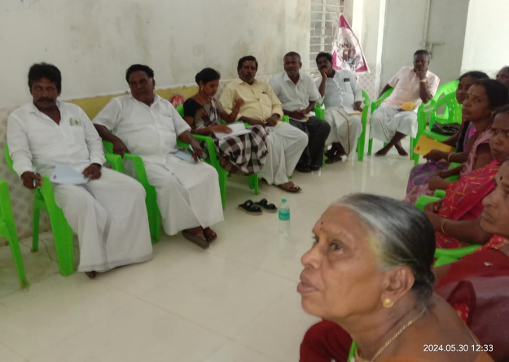
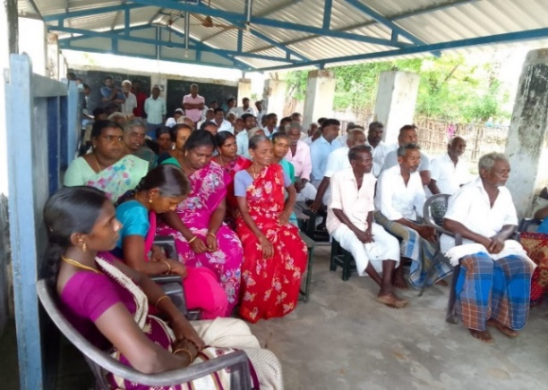
70 members of trade union from Sengankadu and Pettai were trained on the provisions of FRA 2006. They were able to negotiate with forest department to claim their right to navigate in the river and engage in trap fishing and capture fisheries in Muthupet Lagoon and Sea. This workshop ended up in a resolution for constitution of Forest Rights Committees in Sengankadu and Pettai.

Governance

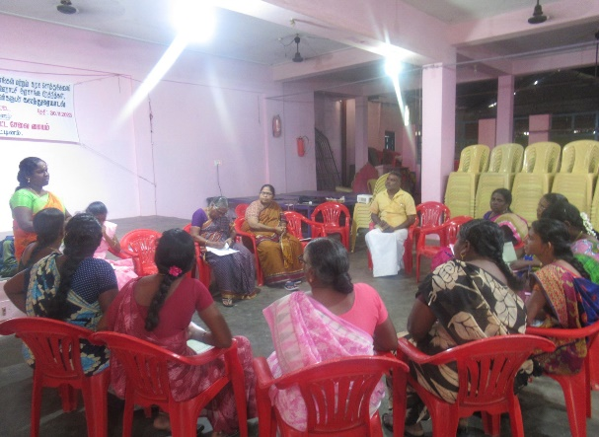
It was decided to document the existing commons and CPR. The Coastal Panchayat should be involved in planning and implementation of coastal development programmes. Devolution of powers and funds for 29 sectors must be shared with the Panchayat Governance. The Panchayat Government to pass resolutions to close all the industrial shrimp farms. The Governance of Village Natham and revenue porambokes must be conferred with the Panchayat Government.
Documentation of coast resources
Reserve Forest Areas in Thiruvarur | Reserve Forest Area in Cuddalore
- Thamarankottai  - Maravakkadu  - Vadakadu  - Thuraikadu  - Muthupet | - Rasapettai,  - Sothikuppam  - Nanjilingampettai,  - Nayakkarpettai  - Chinnoor North,  - Chinnoor south  - C.Pudupettai  - Indira Nagar | - Killai,  - Chinnavaikkal,  - Patrayadi  - Pillumedu,  - Muzhukkuthurai  - Surya nagar,  - Mudasalodai
Name of the Rivers | Name of the Rivers
- Kanthaparichan  - Kilaithangi  - Bamini  - Maravanaru  - Koraiyaru  - Valavanaru | - Uppanar  - Vellar  - Kollidam  - Paravanar  - Gadillam  - Manimuthar

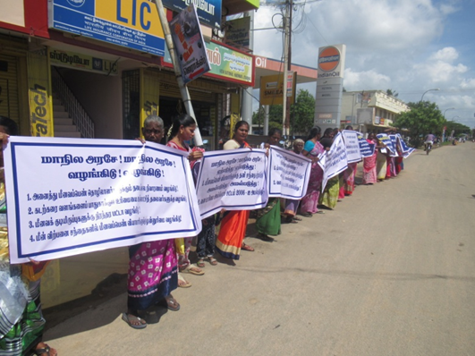
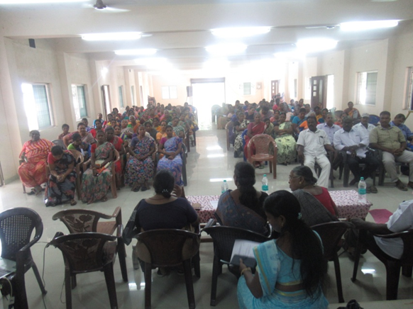
World Fisher people day to advocate for recognition and visibility of traditional fishing communities in policies, legislations and programs of the state.

During the observation day of world fisher people held at Muthupet and Cuddalore the speakers and the participants advocated for Delimitation of coastal panchayats, Reservation for traditional fishing communities and inclusion of traditional fishing communities as sea tribes by constitutional amendments under 7th schedule and include them in the SC/ST category
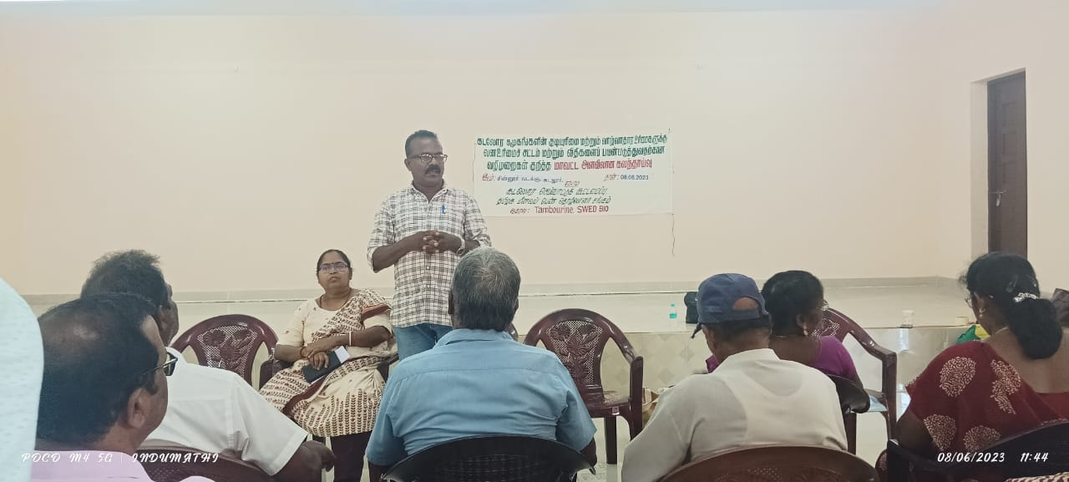
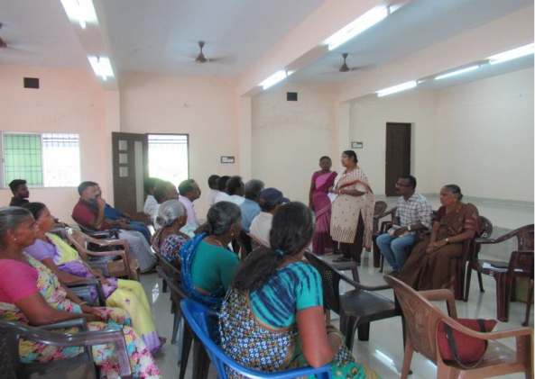
Trained on salient features of forest rights act at Cuddalore on 08.06.2023 and Muthupet on 07.06.2023

Conceptual inputs on the relevant provision of Forest Rights Act 2006 to members of Pettai and C. Pudupettai coastal panchayat.
Other traditional forest dwellers”: anyone who has, for at least 3 generations prior to the 13th of December 2005, primarily resided in and depended upon forest or forest

land for bona-fide livelihood needs. The distribution of the titles is but an important and necessary step. The act recognizes the symbiotic relationship between the forest communities. It attempts to deal holistically with the issue in terms not only of the recognition of rights but of livelihood opportunities, environmental protection and

conservation. If implemented in its true spirit this Act will provide significant multipliers in the processes of economic development resource dependent communities.

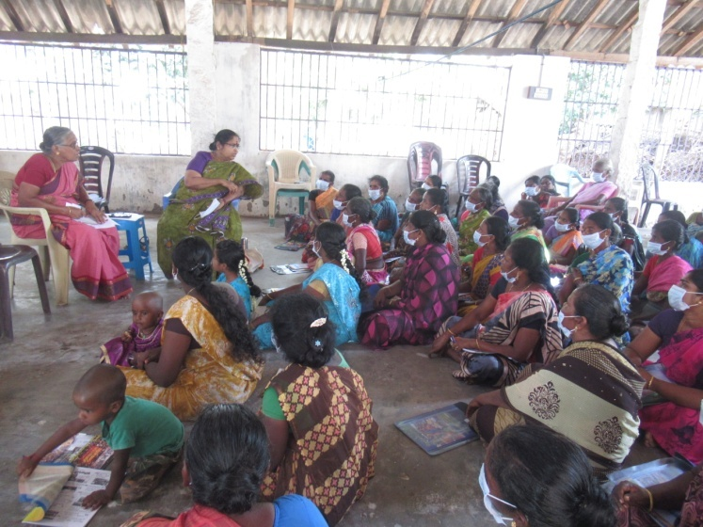
Livelihoods of Fisher Women
80 fisher women were supported with a grant of ₹4lakhs for investment capital who were engaged in the various activities. The women seafarers and oyster collectors are heavily indebted and they are not able to earn a subsistence income as they have to sell the catch to the money lenders. Moreover, they have to accept the price fixed by the buyer. If they have money to invest for seafaring activities (access to net, boat, ice box, vending, vessels etc.,) they can fetch relatively a better income to the family. They use 10 kinds of nets to catch prawn, crab and different species of fishes with different net size. They sought the support of Law Trust.
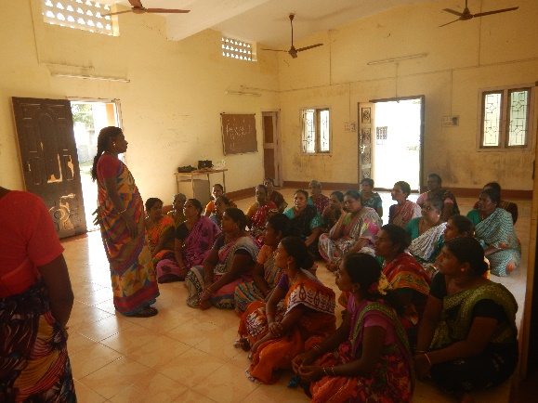

386 women are supported with a revolving grant of Rs 14 lakhs, who were engage in the various activities like auctioneer, Head loaders, Fish vendors and Dry Fish vendors

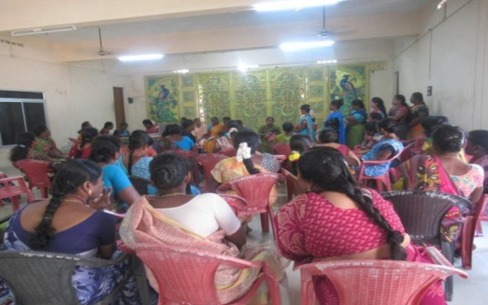
Women are sensitised on their gender and sectoral rights at Cuddalore district on 22.12.2023
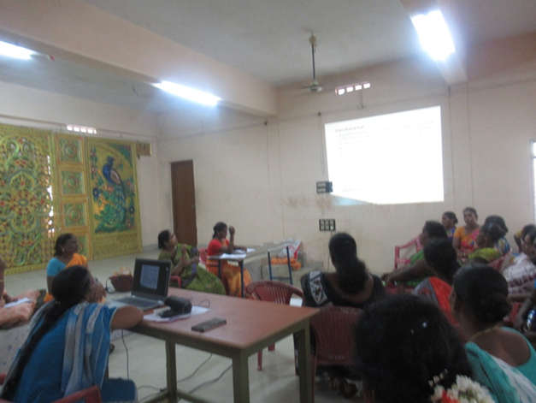
Child Rights
Children were trained on protection and participation rights
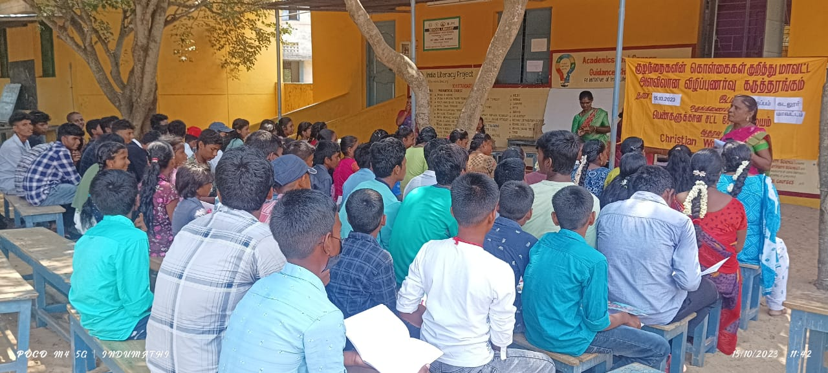
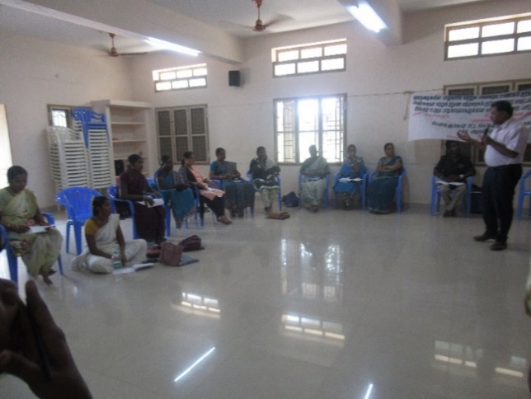
Representatives of Coastal NGO got trained on the important child rights legislations and Institutional mechanisms to protect children from all forms of violences and securing participation rights for children.

Overall impact

Our present Donars
Christian world service,Newzealand since 1996
Swedbio, Sweden since 2019
Tambourine, New Zealand since 2022
Join us in our mission
Coastal communities are on the frontlines of climate change, battling rising sea levels, destructive storms, and dwindling natural resources. These challenges not only threaten their homes and livelihoods but also their rich cultural heritage and ecosystems.
We need your support to make a difference.
- Provide emergency relief supplies to families affected by natural disasters.
- Fund sustainable livelihood projects to help communities rebuild and thrive.
- Support education and training programs to prepare communities for future challenges.
- Contribute to environmental restoration and protection of coastal ecosystems.
Every contribution, no matter how small, brings hope and resilience to these communities. Together, we can safeguard their future.
Donate today and be a lifeline. Your donations are exempted under 80G and 12A of Income Tax Act, India.
Thank you for standing with coastal communities in their time of need!
Our appeal
Distribution of food, clean water, medical supplies, and temporary shelter for families affected by storms and floods.
Thiruvarur District
Emergency Relief Supply to single women
Requirements | No of Beneficiaries | Unit Cost  Rs | Total Cost
Taurpline for households | 200 | 5,000 | 10,00,000
Temporary shelters | 100 | 80,000 | 80,00,000
Dry ration package | 150 | 2,000 | 3,00,000
Blankets | 100 | 300 | 30,000
Notebooks | 509 | 150 | 76,350
Raincoats to children | 509 | 800 | 4,07,200
Sustainable Livelihood Projects (25%)
Support for fishing activities
Nets | 150 | 3,000 | 4,50,000
vending accessories | 150 | 2,000 | 3,00,000
Ice box | 150 | 3,000 | 4,50,000
Medical Kit | 509 | 300 | 1,52,500
Sanitary package nu | 509 | 100 | 50,900
1.Cuddalore District
Emergency Relief Support to Single women/Women headed Family

Requirements | No of Beneficiaries | Unit Cost  Rs | Total cost
Taurpline for households | 50 | 5,000 | 2,50,000
Temporary shelters | 10 | 80,000 | 8,00,000
Dry ration package | 100 | 2,000 | 2,00,000
Blankets | 150 | 300 | 45,000
Notebooks | 245 | 150 | 36,750
Raincoats to children | 245 | 800 | 1,96,000
Sustainable Livelihood Projects (25%)
Support for fishing activities
Nets, | 100 | 3,000 | 3,00,000
vending accessories | 50 | 1,500 | 75,000
Ice box | 50 | 3,000 | 1,50,000
Medical tool Kit | 245 | 300 | 73,500
Sanitary | 245 | 100 | 24,500

Experiential sharing by member of TNWFS
Restoring Customary and Governance Rights to Coastal Commons
Our story starts with a rescinding note that we are being uprooted from our ancestral homes, denied access to navigate the pathways of Vellar, Uppanar, Pitchavaram lagoon and the Bay of Bengal to catch our wild species both small and big and prawns and crabs, oysters near mangroves.
Coastal commons of our traditional communities which served us our livelihood needs, protected us from furies of nature, our freedom to live a dignified life with sustenance and right to celebrate life with the rhythm of waves which were carrying messages from our ancestors to cope up with the challenges. Our mangroves, our rivers, backwaters, lagoon and the sea kept us with synergy and lead our life in the serenity of our blissful nature.
It was in 2014, Law Trust engaged us in Resource Mapping where we recollected our memories to identify the existing resources which are very much essential for our survival because of the valuable ecological services offered by them.
List of Resources
Coastal stretches, Mangroves, Corals and coral reefs, Sand dunes, biologically active mudflat, Salt marshes, Turtle nesting grounds, Horse shoe crabs, habitats, Sea grass beds, Nesting grounds of birds, Habitats, Landing sites, Net mending centres, Land areas for future expansion, Rivers, Creeks, Ponds, Lakes.
We were asked to record the status of these ecological resources and their services. We realised that our coastal stretches are permitted for Industrial and Infrastructure projects. Our Killai region lost the access to the drinking water as shrimp farms were proliferated and approximately 200 farms are active and engaged in Industrial Aquaculture and all these farms drain their un treated effluents into the Vellar and Uppanar River.
2018 Satellite Imagery of Chinnavaikkal Barmouth

2024 Satellite Imagery of Chinnavaikkal Barmouth

In addition to this the silt has accumulated in the Riverine Ecosystem and Mangrove Regions and there in no influx of water from the Sea to the River and vice versa near the Barmouth in Chinnavaikkal and we have to make a roundabout route to reach the sea.
Chinnoor North, Cuddalore
Our learnings and hands-on training to locate the waypoints in the Google Map helped us to compare the status of these resources in the previous years since 1991. These insights are useful to review the Coastal Zone Management Plans and Maps (CZMP) in 2018 under Coastal Regulation Zone Notification 2011(CRZ).
We gathered during the Public Hearing held at the premises of the District Administration and protested against the gaps and non-engagement of Primary Stake holders. Our State level Forum Coastal Action Network filed a case against the gaps and violations. The National Green Tribunal (NGT) directed the SCZMA
to redo the Maps and Plans. We are using this Community Science at present to critique the CZMP Maps released under CRZ Notification 2019. We also learnt that the Mangrove wetland and the coastal and riverine ecosystems are brought under Reserve Forest area.
We are now prohibited to have access to our Coastal and Ocean commons as they are brought in to the fold of Reserve Forest. The MoEF and CC in its Coastal Regulation Zone Notification 2019 under Annexure I defines that the ESAs maintain the biological integrity of the coast by providing direct and indirect ecosystem services to the coastal livelihood. In addition, several invaluable archaeological and heritage sites are also located along the coast. Hence conservation and protection of the above areas, features and sites become necessary. All ESAs shall be identified and boundary delineated by National Centre for Sustainable Coastal
Management (NCSCM)using satellite data. We were not aware of the consequences of this Annexure.
Action Plan
We are now in the process of constituting Gram Sabha and Forest Rights Committee under Forest Rights Recognition Act 2006. We are of hope that we will reclaim our rights using the provisions of the Act.
Let us restore our Rights! Let us represent our Governance!
Let us redistribute our Resources!
Video Bite (Transcript)
Ms. Backiyam, Chinnoor North, Cuddalore
My name is Backiyam. I am a dry fish vendor from Chinnoor North which is part of Pudupettai Coastal Panchayat. Our family had been living here for many generations. We used to reach the sea via Vellar River which is nearly 2 kms from link road. Our Panchayat used to maintain link road for this pathway to the river. We used to land our boats along the banks of the Vellar river and we have a drying yard and net mending centre. 4 years back the Forest Department prevented us from using this path and this pathway couldn’t be maintained for regular use. They have evicted 140 households and now they are claiming that we cannot navigate river Vellar, land our boats, access to drying yard and fish mending centres. Our Customary and Governance Rights to Coastal Commons are at stake.

